Assignment Description
- Write a program that reads words from a text file and displays all the nonduplicate words in ascending order.
- Write a program to store pairs of each state and its capital in a map. Your program should prompt the user to enter a state and should display the capital for the state.

1 Readme Documentation
The first program reads words from a text file, stores nonduplicate words in a C++ set, and then prints them in alphabetical order

2 Flowchart Screen Shots
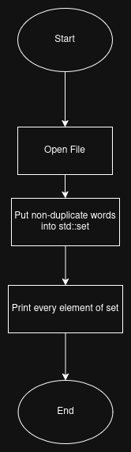
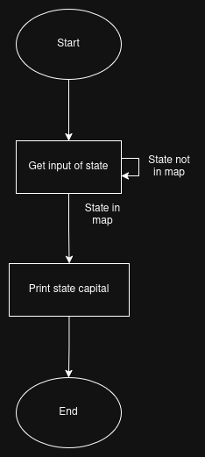

3 UML and Use Case Diagrams
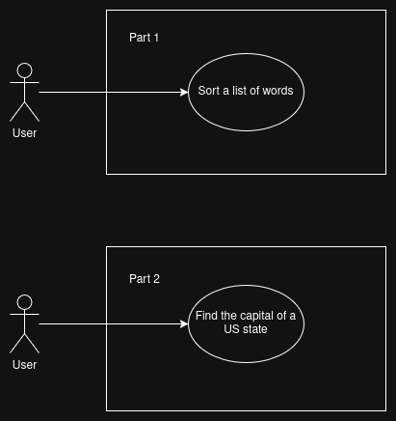

4 Source Code of All files (.h, .cpp)
Part 1:
#include <iostream>
#include <fstream>
#include <string>
#include <set>

int main(){
std::ifstream f("part1.txt");
std::set<std::string> words;

std::string line;
while(getline(f, line)){
if(words.find(line) == words.end()){
words.insert(line);
}
}

f.close();

std::cout << "This is your list of words in alphabetical order: " << std::endl;
for(std::string word : words){
std::cout << word << std::endl;
}

return 0;
}

Part 2:
#include <iostream>
#include <map>
#include <string>
#include <algorithm>

std::map<std::string, std::string> stateCapitals = {
{"alabama", "Montgomery"},
{"alaska", "Juneau"},
{"arizona", "Phoenix"},
{"arkansas", "Little Rock"},
{"california", "Sacramento"},
{"colorado", "Denver"},
{"connecticut", "Hartford"},
{"delaware", "Dover"},
{"florida", "Tallahassee"},
{"georgia", "Atlanta"},
{"hawaii", "Honolulu"},
{"idaho", "Boise"},
{"illinois", "Springfield"},
{"indiana", "Indianapolis"},
{"iowa", "Des Moines"},
{"kansas", "Topeka"},
{"kentucky", "Frankfort"},
{"louisiana", "Baton Rouge"},
{"maine", "Augusta"},
{"maryland", "Annapolis"},
{"massachusetts", "Boston"},
{"michigan", "Lansing"},
{"minnesota", "Saint Paul"},
{"mississippi", "Jackson"},
{"missouri", "Jefferson City"},
{"montana", "Helena"},
{"nebraska", "Lincoln"},
{"nevada", "Carson City"},
{"new hampshire", "Concord"},
{"new jersey", "Trenton"},
{"new mexico", "Santa Fe"},
{"new york", "Albany"},
{"north carolina", "Raleigh"},
{"north dakota", "Bismarck"},
{"ohio", "Columbus"},
{"oklahoma", "Oklahoma City"},
{"oregon", "Salem"},
{"pennsylvania", "Harrisburg"},
{"rhode island", "Providence"},
{"south carolina", "Columbia"},
{"south dakota", "Pierre"},
{"tennessee", "Nashville"},
{"texas", "Austin"},
{"utah", "Salt Lake City"},
{"vermont", "Montpelier"},
{"virginia", "Richmond"},
{"washington", "Olympia"},
{"west virginia", "Charleston"},
{"wisconsin", "Madison"},
{"wyoming", "Cheyenne"},
{"district of columbia", "Washington"}
};

std::map<std::string, std::string> properNames = {
{"alabama", "Alabama"},
{"alaska", "Alaska"},
{"arizona", "Arizona"},
{"arkansas", "Arkansas"},
{"california", "California"},
{"colorado", "Colorado"},
{"connecticut", "Connecticut"},
{"delaware", "Delaware"},
{"florida", "Florida"},
{"georgia", "Georgia"},
{"hawaii", "Hawaii"},
{"idaho", "Idaho"},
{"illinois", "Illinois"},
{"indiana", "Indiana"},
{"iowa", "Iowa"},
{"kansas", "Kansas"},
{"kentucky", "Kentucky"},
{"louisiana", "Louisiana"},
{"maine", "Maine"},
{"maryland", "Maryland"},
{"massachusetts", "Massachusetts"},
{"michigan", "Michigan"},
{"minnesota", "Minnesota"},
{"mississippi", "Mississippi"},
{"missouri", "Missouri"},
{"montana", "Montana"},
{"nebraska", "Nebraska"},
{"nevada", "Nevada"},
{"new hampshire", "New Hampshire"},
{"new jersey", "New Jersey"},
{"new mexico", "New Mexico"},
{"new york", "New York"},
{"north carolina", "North Carolina"},
{"north dakota", "North Dakota"},
{"ohio", "Ohio"},
{"oklahoma", "Oklahoma"},
{"oregon", "Oregon"},
{"pennsylvania", "Pennsylvania"},
{"rhode island", "Rhode Island"},
{"south carolina", "South Carolina"},
{"south dakota", "South Dakota"},
{"tennessee", "Tennessee"},
{"texas", "Texas"},
{"utah", "Utah"},
{"vermont", "Vermont"},
{"virginia", "Virginia"},
{"washington", "Washington"},
{"west virginia", "West Virginia"},
{"wisconsin", "Wisconsin"},
{"wyoming", "Wyoming"},
{"district of columbia", "District of Columbia"}
};

int main(){
bool running = true;

while(running){
std::cout << "Please enter a US State to see the name of its capital. Enter 0 to exit. " << std::endl;

std::string input;
std::getline(std::cin, input);

if(input == "0"){
running = false;
break;
}

std::transform(input.begin(), input.end(), input.begin(), ::tolower);

if(stateCapitals.find(input) == stateCapitals.end()){
std::cout << "State not found!" << std::endl;
continue;
}
else{
std::string capital = stateCapitals[input];
std::cout << "This is the capital of " << properNames[input] << ": " << capital << std::endl;
}
}

return 0;
}

5 Three Use Case Screen Shots
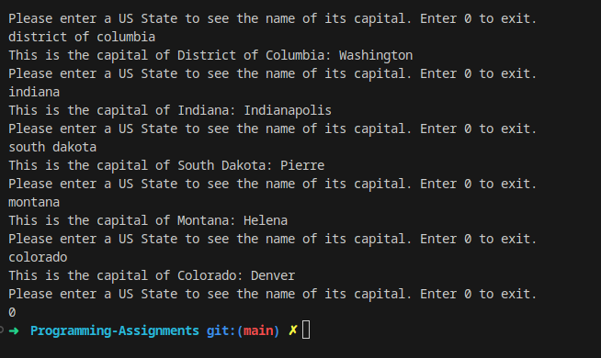

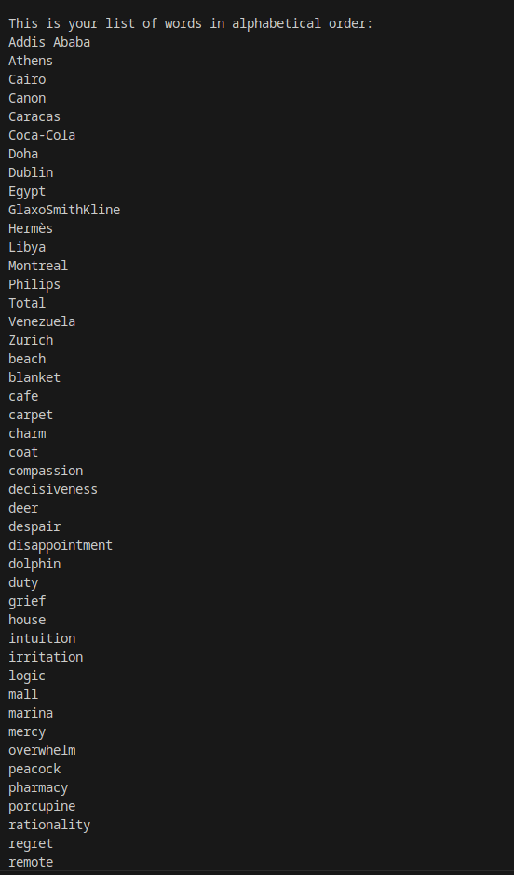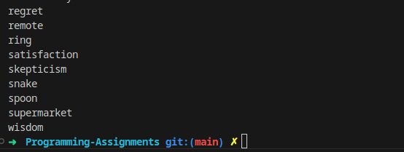

(Optional) GitHub URL

